Joint NGO Urgent Appeal
Special Procedures of the Human Rights Council

14 JULY 2008

Submitted by

MINBYUN-Lawyers for a Democratic Society, PSPD-People’s Solidarity for Participatory Democracy, Korea Women’s Association United (KWAU), Korean Progressive Network Jinbonet, NGOs in Special Consultative Status with the Economic and Social Council of the Untied Nations, GONGGAM-Korean Public Interest Lawyers Group, SARANGBANG Group for Human Rights, , MINKAHYUP Human Rights Group

In association with

Busan Human Rights Center, Committee of Sexual Minority of KDLP, CHINGUSAI, Lesbian Counseling Center, Committee to Support Imprisoned Workers, Dasan Human Rights Center, Disability and Human Rights in Action, Human Rights Center for Disability, Human Rights Solidarity for New Society, Korea Research & Consulting Institute on poverty, protesting against poverty and discrimination Solidarity for Human Rights, Migrant Human Rights Solidarity, The Korean Council for the Women Drafted for Military Sexual Slavery by Japan, Ulsan Human Rights Solidarity

Contact Information
Mr. Dong-Hwa LEE / International Coordinator
MINBYUN-Lawyers for a Democratic Society
5F, Shinjeong B/D, 1555-3, Seocho-dong, Seocho-gu, Seoul, Republic of Korea,
P.O. 137-070
Tel : +(82)(2) 522-7284 Fax : + (82)(2) 522-7285 E-mail : m321@chol.com

◆ Outline of the Urgent Appeal ◆

(1) Extreme Failure of the Government Policy
During Korea-US negotiations on beef import,
-Although it was an important agenda related with the right to health and the right to eat healthy food,
-The government changed its original stance in just a few hours and completely complied to the US position,
-During the process, the government completely ignored the public opinion,
-There was no trace of transparency whatsoever during the process.

(2) Initial Responses of the People
MBC's critical report on this matter triggered movements such as,
-Internet became a forum for various opinions
-People started candle-lit assemblies to express resistance
-Festivals initially started by young students spread throughout the whole country.

(3) Initial Response of the Government to the Public Movement
The Government denied its policy failure
- made its irresponsible comments such as "Don't buy it if you don't want to it."
- labeled the public opinion as "rumors"
- stressed that there is a "background" for the public resistance.
-stated that it has no choice but to take harsh actions against "violent demonstrations" when the actual assemblies had been peaceful throughout.
-began a search for the source of the "rumors," the "background," and the participants of the "violent demonstrations."

(4) Continued Civil Resistance and the Government's Systematic Oppression
The Government has shown no intention to communicate with the public so far, and the angry public continued resisting by having assemblies and marching.
During the process, the Police responded with force, arrested about 1000 people, and injured thousands of people.

(5) Continuous and Systematic Oppression by the Government
Right after the additional negotiation with the U.S. government,
-The President sued some media organizations for the charge of libel
-MBC, which was the start of critical opinions, is now under government investigations
-The Government is increasing its control over internet media by ordering internet portal sites to erase users' writings that request for less advertisement on some Government-friendly papers and arresting people who wrote critical opinions on Government policies.
-The Government arrested main leaders of the People’s Association for Measures against Mad cow Disease, an organization made of 1700 different NGOs and seizured and searched the office of the People’s Association for Measures against Mad cow Disease.
-The Government blockaded the City Hall Square, where assemblies usually take place, to stop assemblies from happening.
-The Government defined the movement as impure, and made it seem like an ideological movement.
-The President is claiming that candle-lit assemblies are the cause of the current economic crisis, and it is expected that there will be more systematic oppression on the assemblies.

(6)Requests
▶ Confirm that there have been violations of the freedom of speech and other basic rights and urge for punishment of people in charge.
▶ Be aware of the seriousness of the situation and express a stance directly and openly
▶ Start a direct involvement such as the Country Visit investigation.

<Urgent Appeal>

[The promotion and protection of the right to freedom of opinion and expression]
◎Background
1. The ROK government decided to open its market to U.S. beef with SRM
Inaugurated on February 25 this year, on April 18, the new President Myung-bak LEE agreed to alleviate U.S. beef import restrictions which had banned beef from cattle 30 months of age or older. The deal leaves South Korea vulnerable to Specific Risk Material (SRM). Considering eating habits of Koreans that virtually consumes all parts of the animal, internal organs, bones, and few other parts were once banned due to its risk of SRM. That is, Lee's two-month-old government agreed to U.S. all-parts beef imports ignoring continued efforts so far made to strictly regulate the imports on the body parts and age.
Currently, in South Korea, there is high opposition of its citizens to U.S. beef imports sparked by fears of mad cow disease, and its government is using various means necessary, even compulsory ones, to carry out its deal with the U.S. disregarding the voice of its people. The government dares to violate the freedom of expression of its citizens while doing so.
From the beginning of candlelit assemblies on May 2, the government has been maintaining its invasive and hard-line measures to curb its citizens' opposition, and the measures are so diverse and vast that the people's freedom of expression is being severely infringed. The public prosecutors' investments on the TV programs that deal with the mad cow beef issue, issuance of delete orders for the Internet postings opposing U.S. beef imports, the police's attempts to blockade the candlelit assemblies, forcible arrest, dispersal, and detention, issuance of dismantlement order for banners with opposing messages at a district office, and other invasive and hard-line measures are still enforced.

2. Repressing the peaceful candlelit demonstrations and restraining expressive objectives
An Internet portal site, www.agora.daum.net, initiated the candlelit demonstrations. At its petition section, netizens voluntarily led several signature-seeking campaigns including a petition called 'Urging legislation of a special law to abolish the hasty U.S. beef import deal' that engaged an estimated one million people. Candlelit demonstrations are also the case that all the discussions and suggestions went on on-line realized off-line. In the evening of May 2 at the Chunggye Plaza, Seoul, a candlelight festivity demanding the annulment of the U.S. beef import agreement engaged an estimated one ten-thousand people. In the early stage, the demonstrations went on without any organizers so that members of the Internet sites that are against the mad cow beef imports such as www.michincow.net took the host role (Sung- Gyoon Baek, operator of www.michincow.net), and participants freely had speeches and sang. The demonstrations are peaceful and voluntary that even Korean celebrities including Jang-hoon Kim, Do-hyun Yoon, Hee-eun Yang, and Seung-hwan Lee voluntarily participated in these demonstrations with some songs and opinions.
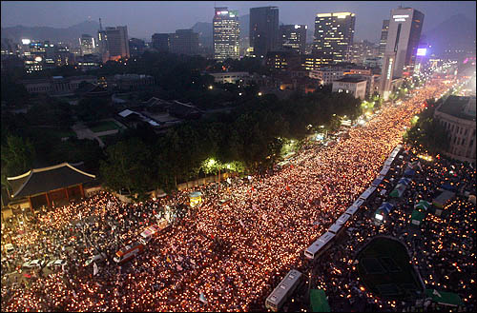
▲ Candlelit demonstration participants
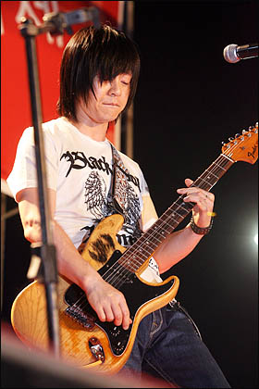
▲ Singer Do-hyun yoon singing at a filling up the roads completely candlelit demonstration (5.17.2008 Chunggye Plaza)

These assemblies aren’t held just in Seoul. On May 3, spreading in Busan, Daegu, Incheon, Gwangju, and Chuncheon, they are now held in many big and small cities nation-wide. Not only taking place in South Korea, but these peaceful demonstrations also took place in Berlin, Frankfurt, Paris, and Auckland by overseas Koreans.
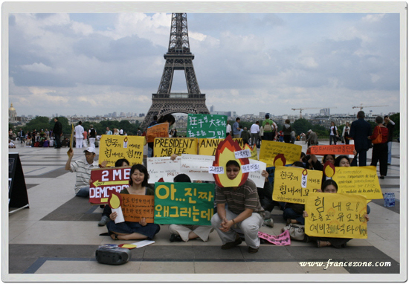

▲ A candlelit assembly held in Paris, France on June 1

The general public, not owning the mass media, can ensure not only a place to express themselves but also a way to express their opinions and demands through participating assemblies and demonstrations. This is a typical expression of "political and democratic basic rights" and has significance as communication between a country and its citizens and as protection of the minorities. Nevertheless, the government prescribes these candlelight assemblies as unlicensed and illegal and continues to deal with them with violent dispersal, arrest, and search.
Furthermore, fears of mad cow disease are spreading rapidly through thousands of opposition postings per day on the free bulletin board of the Blue House homepage. However, the government is widely limiting such communicating and expressing activities on the Internet. Disparagement of mad cow disease fears of its citizens as 'Mad Cow Myth', arrangement of a team to look after this whole issue within the prosecutors office, organization of an investigation team on the no-buy campaign targeting some daily news papers that are accused of distorting the mad cow demonstrations, issuance of delete orders to the Internet postings that are suggestive of the boycott, and others are going on to limit the freedom of expression on the Internet. Various ministries and offices of the country such as the police, the prosecution, district offices, the Seoul municipal office, the Ministry of Education and Human Resources Development, the Ministry of Food, Agriculture, Forestry and Fisheries, and the Ministry of Public Administration and Security are busy curbing the candlelit assemblies. As of now, mad cow demonstrations have been going on for over two months, and every demonstration engages hundreds of citizens at the minimum and hundred thousands at the maximum. Yet the freedom of expression of the citizens is infringed in many ways and at a severe level. Currently, a special investigator is visiting South Korea in order to look into the present conditions of human rights violation at the rally.

The term, candlelight assembly, refers to an assembly with candle lights, and the candle lights are lit in the participants’ hope of their opinion and suggestions to be heard. Most of the participants hold a candle light on one hand and a picket on the other. There wasn’t a case that participants prepared for any sorts of arms in prior to demonstrations. Because candlelit demonstrations are safe and peaceful, families with children, pregnant women, and even young couples with their newborn babies can join them.

Rather the citizens prepare masks, rain outfits, and umbrellas to safeguard against water cannon and fire extinguisher shootings of the police, which meant to disperse them. They are encouraging themselves to maintain their assemblies nonviolent and peaceful, and at the same time they are proud of themselves and their assemblies. Sponsored by the Medical School of Wonkwang University and some Internet clubs, the picture below is a hand-out depicting necessary goods for a rally made by the citizens themselves. The hand-outs were provided at rallies. Its title is “My little effort for a beautiful candlelit festivity,” and the subtitles include ‘no violence’, ‘maintain order’, ‘a clean assembly’, and ‘senses of citizenship.’ Its recommended goods are something to sit on, a rain outfit, a bag for trash, a picket, a candle light, a mask, and a digital camera.

Violent situations at these rallies are very rare, and even these situations occur in response to the violent riot police. For example, the riot police blockaded the whole roads using police buses in order to intercept the marching mass on their way to the Blue White. The people tried to pull off an empty bus out of the roads, and in doing so the police bus was damaged.
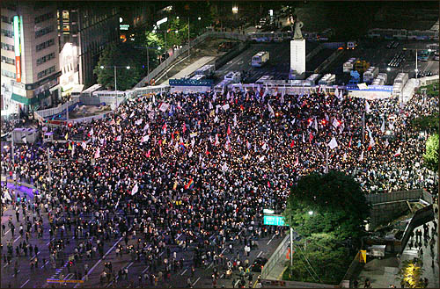
△ Sejongro, 16 lanes both ways, is the widest road in Seoul. The police blocked the Sejongro with police buses in order to intercept the marching citizens.
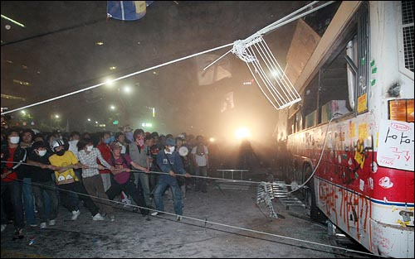
△ Encountered with the blockade, the mass tried to pull off the empty police bus.

3. Human rights violation of the Law of Assembly and Demonstration
When hundreds to hundred thousands citizens has been participating candlelight assemblies over two months, the police (Eo Cheong-soo as chief of the National Police Agency) prescribed these assemblies as against the law. Accordingly, they had six wanted and three detained, and eight were arrested at the rallies. The law the police base on to prescribe these rallies unlawful is the one that has been criticized for violating the freedom of assembly ensured by the constitution. For example, there are bans limiting assemblies after sunset, on major urban roads, and noise above 80db. Above all, it is a report system. however the chief of the National Police Agency can have negative commands on assemblies. The police are infringing the freedom of expression by arbitrarily banning demonstrations based on their abstract reasons such as inconvenience to traffic and threat to public welfare and order. In addition, when an organizer did not report its assembly in advance, stipulating it as illegal, the organizer is subject to criminal penalties. However, despite the fact that reports are needed to have both the police and the protesters cooperated for safe assemblies, lack of a report can cause the organizers criminal penalties. It is substantially liming their fundamental rights.

These rallies are engaging citizens with various groups at various ages including middle and high school students, seniors, housewives, and office workers. On the Internet, they had discussions regarding their assemblies and promoted as many people as possible to join them. Participants voluntarily gathered around 7 p.m. after work at the central Seoul. Due to the peculiarity of these assemblies, applying the statutory ban of the Law of Assembly and Demonstration and prescribing illegality to them are infringing the fundamental purpose of assembly and demonstration.

◎ Cases of violation
1. Violations related to assemblies
- Prescribing a peaceful assembly as a unlawful one
Ever since candlelit rallies broke out, the police have maintained its hard-line policy towards them. On May 4, right after the very first two assemblies were held peacefully on May 2 and 3, a person at the Seoul Metropolitan Police Agency announced that related persons to the Internet sites that led the rallies would be summoned and punished and that the rallies are unlawful saying “We found some unlawful elements in the candlelit assemblies due to their strong political-assembly-like characteristics that are more than mere cultural events.” Furthermore, the person stated, “We believe there will be more candle light assemblies in the future, and we will come up with powerful warning and countermeasures to the future assemblies.” Hereafter, the police have been prescribing these demonstrations illegal in accordance with the Law of Assembly and Demonstration while punishing organizers and participants. As of today, there are over a thousand people taken to the police station and eight people detained due to the candlelit demonstrations.

- Blocking the Marching
People usually gather around for their demonstration at about 7 p.m., after school and work. For about 2 hours they sat on the City Hall making speeches freely and enjoying performances of others, and they march around the central Seoul. Because the police always organize the riot police and police buses to blockade all the roads that go to the Blue House, a marching takes a course that is not intercepted by the police. When an assembly goes on overnight, people go on with it sitting on the roads blocked by the police talking and singing. Days without forced repression by the police to disperse the mass, by the office-going hour citizens disperse voluntarily after cleaning up their demonstration site.

- Violent dispersion tactics
Dispersion tactics of the police for assemblies would remind anyone of a warfare. The police shoot water cannons and fire extinguishers directly on the faces of citizens and throw dangerous objects such as dumbbells at. They even attack participants whom they can get their hands on. There was an incident that the police attacked a girl again after she escaped from the attack.
▶ video of water cannon. http://kr.youtube.com/watch?v=B4cLO5qls0Q&NR=1
▶ video of attacking a college woman. http://kr.youtube.com/watch?v=SspSf5Zojpo
Line by line, people lay down on the roads locking arms with one another in order to resist being arrested by the police, and the police walked on the people with their billies and shields that caused severe injuries. On June 29, the National General Secretary of YMCA Lee Hack-young, who suggested the lie-down campaign, fractured his arm lying down on the streets.
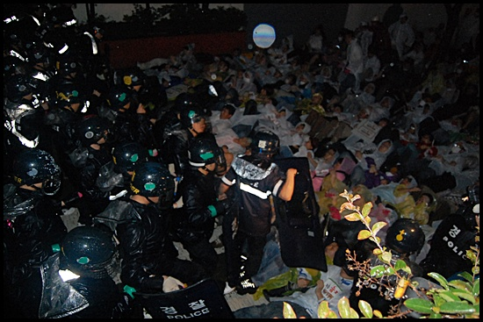
△ June 29, the police walked on the lying citizens.
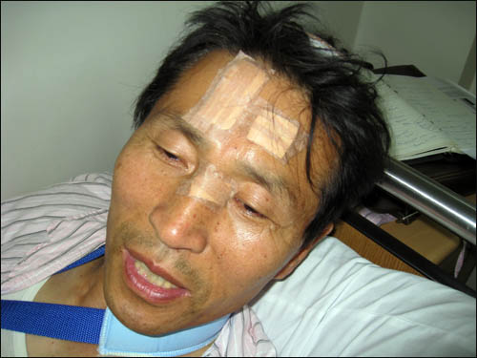

△ Lee Hack-young, the National General Secretary of YMCA was admitted to a hospital due to his fractured bone.

- Safety is missing, and punishment is the goal.
The police also announced that they would put dye and tear liquid into their water cannons. That is, they will find people with the dye and punish them. Such an announcement is not to dissolve an assembly but to punish its participants. This shows the police’s intention to reduce and interrupt the assemblies through such a threat of punishment.

- Detaining and adding to the wanted list the related persons to the People’s Association for Measures against Mad Cow Disease (hereafter People’s Association)
Because massive assemblies were holding on a daily basis, an estimated 1700 civic groups organized an association to come up with countermeasures. The association not only directs demonstrations and delivers donated money and goods to the participants, but also grasps the situation of arrested and injured citizens while providing them with medical and legal supports. Its administrative works are divided among activists from each civic group. The police issued arrest warrants for nine administrative staffs in the group and arrested three of them in a violent and illegal way without even informing the Miranda rule. Due to the arrest warrants, the rest are currently at the temple called Jogyesa in Jongnogu, Seoul staging a sit-down demonstration opposing the arrests and the warrants.

-Walls of police buses and containers hindering the march
On June 10, commemorating the same day in 1987 that put an end to the military dictatorship and contributed to a direct presidential election system, more than a hundred thousand people gathered again for a candlelit rally. Naturally, their demand for renegotiation on the mad cow beef imports grew stronger. Massive participants were expected, and the police deterred a march by piling up containers on Sejongro, the widest roads in Seoul. Four-ton containers were welded into a two-story line, and the police formed a wall of riot buses behind. There were riot police troops after the bus wall in order to build a triple line of defense. On the surface of the containers, they painted grease, a kind of lubricant oil, to prevent the citizens from climbing up on them.

Those containers were to discourage the protesters’ peaceful parade. The mobilization of the containers shows the police’s objective to limit the rally rather than ensuring a safe one while protecting the citizens. A candlelit demonstration is a peaceful march with candle lights, but the police prepared many devices to isolate the protesters. This shows the problematic view point of the police regarding assemblies and demonstrations. When it is their duty to ensure and protect the right to association as a basic right in this democratic society, they rather consider it as illegal.
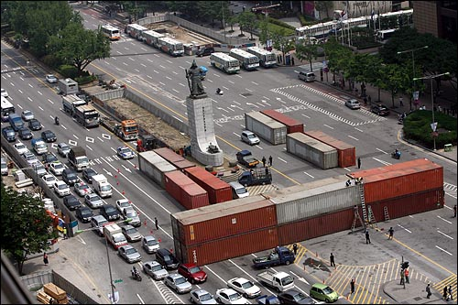
▲ From the morning of June 10, the police is piling up the containers.

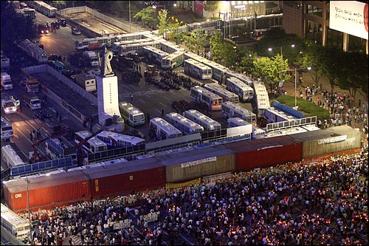
▲The parade had to stop because of the container wall.

- Limiting student participants
For fear that the imported beef will be mainly provided to schools, a lot of middle and high school students eating school meals join demonstrations. According to the 15th article of the UN Convention on Rights of the Child, children are acknowledged to have the freedom to association. However, each middle school and high school took many measures to prevent their students from joining any rallies. The Ministry of Education warned its students that it will punish them if they take part in candlelit demonstrations and sent its teachers to rallies to lookout for their students. The police even visited some student participants during their class hour in order to investigate them, and at the rallies they asked students in their uniforms of their phone numbers to obtain their personal information. All of these were done to cower them from joining the assemblies.

- Confiscating items used in assemblies and detaining the related individuals
The police willfully seized equipments used in the rallies to deter them. On June 28, around 4 p.m. the police took hold of a broadcasting vehicle of the People’s Association for Measures against Mad Cow Disease that was heading towards the City Hall from the entrance of the Namsan Mountain 1st Tunnel, and an estimated 1000 rally participants ran for the spot. The citizens cried out a motto, “Away with Lee Myung-bak,” surrounding the vehicle and the vehicle was able to arrive at the City Hall safely escorted by the citizens.

After all, the police did take an electricity generating vehicle of the mad cow association in Ewhadong, Jongnogu the next day, June 29th, around 1 p.m. Around 2 p.m. the same day, the police stopped a broadcasting vehicle rented from a sound enterprise located in Namdonggu, Incheon on the Seoul-Incheon Expressway when it was entering Seoul. Without a warrant, the police towed the vehicle away from its driver saying it is “an order from the superior.” In the afternoon, the police towed away a stage vehicle that the association set up for the demonstration that day while blockading the City Hall square.

The police explained the actions of distress and towing were in accordance with the 6th article in the Law of Performance of Police Duties. This article states that when it is recognized that a criminal act is about to happen, issue a warning in order to prevent the act. It also states that when there is concern for harms on a life or a body and on a property that calls for emergency, the act can be restrained. However, regarding renting and transporting a vehicle for broadcasting at an assembly as a criminal act is arbitrary and an unreasonable execution of a law as well. The government’s suppression of public peace targeting the candlelit assemblies is being done willfully without meeting legal procedures and requirements, and it is violating the freedom of association fundamentally.

- The police’s collection of pictures without any warrants
Throughout the entire assemblies, the police arranged policemen in charge of taking photos of the faces of participants. These picture-takings take place whether a demonstration is peaceful or violent, and it is an information obtaining activity lacking proper legal procedures such as presenting a warrant. Not only picture-taking violates the Individual’s Right to Control the Circulation of Information Relating to Oneself but also the freedom of association, since this action cowers down the participants psychologically.

- Blocking up the plaza where assemblies are held
Eventually, demonstrators could not use the plaza in front of the City Hall anymore because the place went under construction. The police blocked all the access to the plaza using their buses. A plaza is a public property that all citizens can use it. Although the city of Seoul is only responsible for maintenance of the plaza, so suddenly it closed down the place where had been used for assemblies until then in the reason of grass work mobilizing police force. This is intended to prevent demonstrators from gathering, and it infringes the freedom of assembly and demonstration.
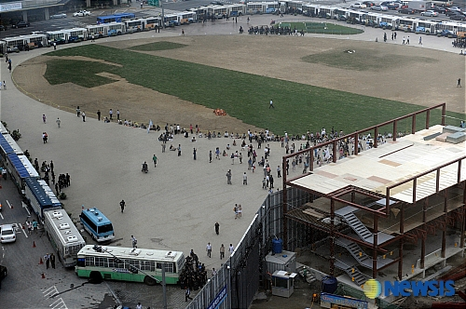
▲ On July 7, the Seoul plaza where had been holding assemblies was blocked by the police buses <Newsis>

2. Violations on representations.

- Arrangement of an investigation team in charge of mad cow myths in the prosecution
The conservative daily newspapers including Josun, Joonang, and Donga belittled the entire general opinion on the Internet by reporting “teenagers are swayed by the spread of groundless myths and wild rumors,” “emotional and extreme collectivism through the Internet,” or “digital Maoism.” Soon after, the prosecution arranged an investigation team in charge of mad cow myths. In the end, the prosecution couldn’t grasp the facts on the matter and promoted overseeing and punishing the Internet postings in order to limit active on-line communication.

- The prosecution’s investigation on the no-buy campaign and its delete orders
For their distorted and government favoring reports, angry citizens initiated an advertiser no-buy campaign targeting Josun, Joongang, and Donga newspapers. The citizens made phone calls and e-mails to the newpapers’ advertisers demanding to stop advertising in these papers. This no-buy campaign was suggested at a discussion section of an Internet site, www.agora.daum.net. Such a campaign can be understood as consumerism that happens commonly in other countries. However, the Korea Communications Standards Commission (Park Myung-jin as chairperson) stated that the Internet no-buy campaign targeting the advertisers of Donga, Josun, and Joongang newspapers is “an act that violates not only norm and order of the society but also the rights of an enterprise” that ordered to delete related 58 postings on the bulletin board permanently. Nonetheless, the Korea Communications Standards Commission is not the machinery of law but a mere civilian independent consultation organization that is established to ensure public welfare and fairness in broadcasting contents. Such an organ included simple postings of a list of advertisers and their numbers into its deleting list is clearly an arrogation. Moreover, this may violates the constitution by limiting the freedom of expression without the Ministry of Justice decided to do so. Additionally, on June 20, Justice Minister Kim Kyung-han directed to strengthen the Internet crime control such as the advertiser no-buy campaign. The prosecution arranged a team called “An Offense of Trust Impediment on the Internet Investigation Team” with five staffs including one senior prosecutor in charge of high-technology investigation at the Seoul Central Public Prosecutors’ Office, and it is currently investigating the no-buy campaign.

No-buy campaigns are based on the consumer sovereignty and the freedom of expression that are included in the constitution, so unless the campaigns are extremely violent or senseless they should be guaranteed in a wider range. The beginning of the investigation by the prosecution means limiting the freedom of expression of citizens, and it has a political aim to atrophy the active no-buy campaign.

- Forced removal of a banner that is against U.S. mad cow diseased beef
On June 24, the Gwanak district office directed a bookstore(‘When the day comes’ in front of the Seoul National University) to remove its banner expressing opposition to U.S. beef imports in accordance with the Enforcement Decree of the Outdoor Advertisements, etc. Control Act. The banner was unlawful because it wasn’t approved in advance. However, the Act states that within 30 days of installation and demonstration of non-profit advertisements and etc. that are used for adequate political activities of an individual or an organization do not need to be reported. The 21st article of the Act also states that “When applying this law, one should be very attentive not to wrongfully invade a citizen’s freedoms and rights such as the freedom of political activity.” The removal order from the district office is being criticized as a rough-and ready control, not thoroughly examining the law, in order to damp down the opposition movement to U.S. beef imports. This provides evidence that mad cow protests are vastly limited by the government.

-The investigation of the prosecution on ‘PD Notebook’
The government (the Ministry for Food, Agriculture, Forestry, and Fisheries) brought a suit to the MBC TV program, ‘PD Notebook,’ for defamation claiming the program spread fallacies about mad cow disease on the show “Is U.S. beef safe from mad cow disease?” broadcasted on April 29. The prosecution organized a special investigation team to look into the program. However, MBC producers and reporters, the labor union of the press, and other related workers are arguing that the on-going prosecution’s investigation is denying freedom of speech and is infringing the freedom as well. That is, “Because evaluation of the program should be done where fair criticisms can be made, it cannot be investigated. And stop this wrongful investigation and requesting submission of related materials.” Moreover, there are strong criticisms for the prosecution’s inability to keep politically neutral as more and more investigations on mad cow disease are going on.

3. Others
- Nation-wide public affairs education for heads of villages, townships, and towns
In the morning of June 30, the government (the Ministry of Public Administration and Security) held the ‘Presentation of National Affairs for Heads of Villages, Townships, and Towns Nation Wide’ to explain pending problems of U.S. beef imports. Out of 3504 heads in total, more 90% of them, an estimated 3300 heads attended the presentation. At the presentation, Minister Won Sei-hoon of the Ministry of Public Administration and Security stated, “the government is doing its best to ensure the right to health while importing U.S. beef, but citizens can’t see our efforts that they are feeling insecure.” He also requested of the headmen “who are responsible for first-line administration to actively communicate with their residents.” After the military dictatorship, it has been 20 years since the government gathered its headmen of villages, townships, and towns to educate them its policies. Despite their positions as headmen, they should be ensured with the freedom of expression, however educating them as it happened 20 years ago and requesting them to promote the government policies are limiting the freedom of speech of citizens.

◎ Others
Citizens who have been demanding for the renegotiation of the import deal for safe and mad cow disease free U.S. beef are now more distrusting their government after the fruitless reworked pack. Since the government rather prescribed their assemblies unlawful instead of putting effort to work it out substantially with them, the citizens are demanding for more and more, evolved from their initial mottoes that opposed U.S. beef imports and asked for renegotiating.
1. Urging discharge of the chief of National Police Agency for prescribing candlelit assemblies as illegal and for ordering forced repression of the assemblies.
2. Opposing neo-liberalistic policies including U.S. beef imports, privatization of public enterprises, and the Grand Korea Waterway that are ultimately expected to worsen the polarization between the rich and poor.
3. For a long time, the citizens have been actively expressing their opinion over their health concern, however President Lee Myung-bak failed to present a substantial solution to them and rather enforced the beef deal. President Lee should step down voluntarily due to this huge disappointment and opposition of the citizens towards him.
http://blog.naver.com/huruba?Redirect=Log&logNo=90031765193 http://boom.naver.com/BoardRead.nhn?categoryId=1&articleNum=20080629180255010 ▲ Websites for the police’s violation

[Arbitrary Detention]
◎ Background
Since the Korean Government announced the conclusion of “Agreed Minutes of the Korea-United States Consultation on Beef on 18 April 2008, people’s candle-lit demonstration has been continued for more than two months raising an objection to the result of minutes and requiring entire re-consultation in Korean societies. The people ranging from hundreds to hundreds of thousands participated in the demonstration; the demonstration has been held by peacefully gathering with taking candlelight in participants’ hands at Cheonggye Square or the Seoul Plaza in front of Seoul City Hall and by having parade after the meeting; the participants consisted of the students of elementary schools, junior/senior high schools, and colleges, common office workers, housewives, and many network citizens.

However, the Korean Government considered such peaceful meeting illegal by reason of no prior report starting at the initial stage of the meeting and, as the scale grew bigger and the meeting became popularization, started putting pressure by reason of demonstration parade. Starting on May 31, the police supervisor suddenly ordered the citizens on the sidewalk to be dispersed by the only simple reason of gathering and arrested many citizens on the sidewalk by the reason of no obedience to the order of dispersion; the police arrested the persons who had nothing to do with such demonstration including even a 14-year-old student.

In most of cases, Miranda warning was not given or given to the citizens during drawing up a protocol after taking to the police stations; the police continue detaining citizens after drawing up a protocol to fulfill the 48 hours that are allowed only for preparation of arrest warrants in serious criminal defendants.
The police even arrested and detained lawyers who were trying to stop indiscriminate arrests. The lawyers were from an NGO called MINBYUN (Lawyers for a Democratic Society, hereafter MINBYUN).

Therefore, Korean human rights organizations (joint conference of human rights organizations) filed a petition to the National Human Rights Commission of Korea on June 27 and the People’s Association and MINBYUN sued Cheong-Soo Eo, the Chief of National Police Agency, and the officials in charge on June 19 and on July 2.

◎ Cases of Violation

1. Indiscriminate arrests of non-participants and people who were already dispersing
- Mr. Jae-Woo Bae (male, born on February 22 of 1977, works at a magazine company) was watching a demonstration on a sidewalk in front of The Hope Institute, Anguk-dong Crossing, 500 meters away from the crowd at 8 a.m on June 1. At that time, a unit of police suddenly started to attack citizens, and Mr. Bae was surrounded by three policemen and arrested. In this process, the police twisted his arms, hit his forearm with clubs, and pressed his neck hard; later, he had to go to a hospital for physical treatment of muscular pain. Mr. Bae neither heard the order of dispersion from the police nor was not given Miranda warning in such process.
– Seung-Won Na (male, born on April 8 of 1980, a college student) was waiting for a traffic light to change on a sidewalk and was suddenly arrested by the police.
- Mr. Jun-Suk Choi (male, 14 years old, a middle school student) was standing in front of Kyobo Building on a sidewalk; at that time and some policemen came to the sidewalk brandishing their shields; at that time, he was hit by one of the policemen in his back neck and he fell in a faint with bleeding.
- Mr. Song-Tae Park (male, born on February 24 of 1969, a freelancer) came out to buy a hat and met the demonstrating citizens; he followed the crowed for a while and was on his way to a subway station to go back home; at that time, the policemen suddenly surrounded and arrested him.
- Mr. Ji-hoon Chung (male, born on November 27 of 1981, an office worker) watched demonstrating citizens and was on his way home. At that time, he saw citizens being attacked by the police and tried to take photographs but was arrested.

2. Indiscriminate arrests of lawyers protesting against illegal arrests
- On June 25, 2008, the police arrested citizens who were sitting on a sidewalk near to Gyeongbokgung by twos or threes, saying that they did not obey their order to disperse. Upon hearing that the police are conducting an indiscriminate arrest, the lawyers from MINBYUN, Ms. Jae-Jung Lee (female, born on August 2 of 1974) and Ms. Young-Gu Kang (female, born on August 6 of 1977) went to the demonstration site and saw 20 citizens being surrounded by policemen. They protested to the police, asking why they arrested people on a sidewalk. However, the police arrested even these lawyers and detained them in Gangbug Police Station for more than 24 hours.

3. No Miranda warning
- Mr. Su-Yong Kim (male, born on July 24 of 1986, unemployed) was arrested at 7:30 am on June 1 on a sidewalk at Anguk-dong Crossing but Miranda warning was not given at that time but given later during drawing up a protocol in the police station.
- Mr. Jong-Ha Kim (male, born on October 17 of 1987, a college student) was arrested at 23:40 pm on May 27 near to Seoul City Hall on a sidewalk without Miranda warning; he was surrounded by policemen all of a sudden and, when he asked of the reasons for the arrest, he could not get any answers; Miranda warning was not given until he protested later in the police station.
- Mr. Seung-Won Na (male, born on April 8 of 1980, a college student) was arrested on a sidewalk at Anguk-dong Crossing at 7:30 on June 1; Miranda warning was not given to him at the time but was given during drawing up a protocol in the police station.
- Mr. Song-Tae Park (male, born on February 24 of 1969, a freelancer) was arrested on May 28 on a sidewalk in front of Seoul City Hall; Miranda warning was not given at that time and was given in the bus on the way to a police station.
- Mr. Jae-Woo Bae (male, born on February 22 of 1977, works at a magazine company) was arrested on a sidewalk at Anguk-dong Crossing at 8 on June 1; Miranda warning was not given to him at the time but was given during drawing up a protocol in the police station.
– Mr. Ji-Hoon Chung (male, born on November 27 of 1981, an office worker) was arrested on a sidewalk with no Miranda warning; Miranda warning was given to him during drawing up a protocol in the police station.
- Mr. Kyung-Soo Hong (male, born on July 7 of 1969, part-time job) got notified the reasons for his arrest but could not get an opportunity to defend himself.
- Mr. Tae-Sung Kim (male, born on January 6 of 1972, unemployed) was not given Miranda warning at the time of arrest; He demanded his right for Miranda warning as many as two times in the police bus but the policemen barked at him and ignored his request; he was given Miranda warning during drawing up a protocol in the police station.

4. Extended detention after an arrest
- Mr. Su-Yong Kim (male, born on July 24 of 1986, unemployed) was arrested at 7:30 on June 1 on a sidewalk at Anguk-dong Crossing; although the drawing up of a protocol was finished, he was detained until 00:30 of June 3 with no specific reason .
- Mr. Seung-Won Na (male, born on April 8 of 1980, a college student) was released 41 hours after arrest although drawing up a protocol was finished and no further questioning was made.
- Mr. Song-Tae Park (male, born on February 24 of 1969, a freelancer) was released 45 hours after arrest although drawing up a protocol was finished and no further questioning was made; such extended detention damaged his personal business.
- Mr. Jae-Woo Bae (male, born on February 22 of 1977, works at a magazine company) was released 40 hours after arrest although drawing up a protocol was finished and no further questioning was made; he appealed to the policemen saying the false arrest of him and an urgent project for his company but was not immediately released.

[The situation of human rights defenders]
◎ Background
The People’s Association which was organized requesting re-consultation against the import of the whole US beef having mad cow disease with neglecting the health and safety of the people and with abandonment of the rights for quarantine, supports such candle light demonstrations and leads nonviolent and peaceful meetings. However, Korean Government indiscriminately arrested the participants of the meetings, used unspeakable violence in the arrest process, and arrested and detained the targeted staffs of such Conference. Also, they hit a lawyer, who was performing human rights infringement monitoring activity, resulting in a serious condition.

◎ Cases of Violation
1. Case of Mr. Joon-Hyeong Lee, a lawyer from MINBYUN
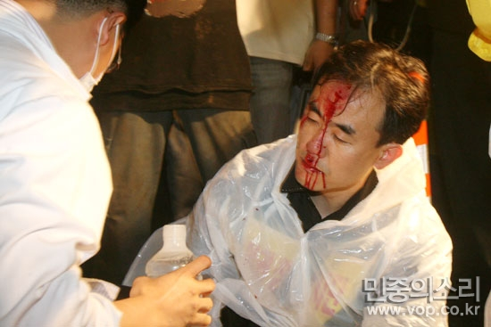
▲ Mr. Joon-Hyeong LEE, a lawyer from MINBYUN
Lawyer Joon-Hyeong Lee(male, 41 years old) from MINBYUN was monitoring possible infringement of human rights wearing a jacket of Human Rights Infringement Monitoring Team on the road between Gwanghwamun Crossing and Seodaemun early in the morning on June 26. At around 01:00, the police started to rush using water cannons and he tried to stop the police standing in front of the citizens to avoid possible injury of them. At around 01:50, the water canons were temporarily stopped and, after a brief respite, combat policemen rushed at citizens with holding their shields at 45° and the citizens stepped back frightened or surprised and then turned back and started to run away. Lawyer Joon-Hyung Lee was stepping back shouting the citizens, “Slowly”; at that time, a unknown combat policeman brandished his shield toward his head and he fell unconscious. Such a unconscious situation was continued for about one hour until he was moved to S.N.U.H (Seoul National University Hospital); his skull was broken and he was suffered internal bleeding with infiltration of air. The bones of brow and around an eye were broken and his brow and philtrum were ripped requiring 14 stitches. His injury was as serious as the physician, who treated him, said that even cerebral contamination was possible if contaminated air infiltrated into his skull.

2. Lawyers Jae-Jeong Lee, Gwang-Joong Kim, from Human Rights Infringement Monitoring Team of MINBYUN
Lawyers Jae-Jeong Lee(female, 33 years old) and Gwang-Joong Kim(male, 32 years old) from MINBYUN performed their activities as the members of Human Rights Infringement Monitoring Team in the early-morning meeting on June 1, 2008, and, in the situation that SWAT dispersing the demonstrators near to Gyeongbokgung at around 04:00, they stood in a line between the demonstrators and the police to prevent possible injury. At that time, lawyers Jae-Jeong Lee and Gwang-Joong Kim wore bands showing the statement, “Lawyers for a Democratic Society of Human Rights Infringement Monitoring Team,” in red on yellow bottoms and they clearly said that they were the lawyers of Human Rights Infringement Monitoring Team; however, they were arrested and taken to a police station for more than six hours. Unknown special attack policemen twisted the forearm of lawyer Gwang-Joong Kim and hit lawyer Jae-Jeong Lee in the shoulder part of left-upper chest with a shield.

3. Cases of lawyer Jin-Geol Ahn, Hee-Sook Yoon, and Sun-Won Hwang from the People’s Association
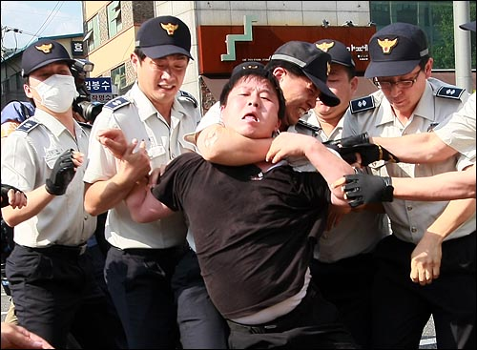
▲ Mr. Jin-Geol Ahn chocked his neck by policemen at Gyeonghokgung Station

Mr. Jin-Geol Ahn (male, 35 years old), a member of People's Solidarity for Participatory Democracy and the Organization Team Manager of the People’s Association, and Ms Hee-Sook Yoon (female, 32 years old), Vice-Chairman of Corea Youth Movement Council, were arrested in front of Gyeongbokgung Station at around 16:00 on June 25 during demonstration for withdrawal of minister’s notification and entire re-consultation. Mr. Sun-Won Hwang, Chief of Democratic Human Rights Division of Korean Progressive Alliance, (male, 32 years old) was placed under restraint with violation of the Law on Meeting and Parade on July 2.
Mr. Jin-Geol Ahn is a staff of Organization Team and took in charge of practical work including discussion on the place and time of candlelight cultural festival in connection with the police. Ms. Hee-Sook Yoon and Mr. Sun-Won Hwang were dispatched to People’s Conference against Mad Cow Disease and tried for peaceful candle demonstration night and day. At the time of arrest, Mr. Min-Geol Ahn saw the indiscriminate arrest of citizens ranging from 12-year-old eliminatory school student to 81-year-old aged person and protested to policemen with the thought that the person of citizen organization could not overlook such situation. In this process, the human right of Mr. Jin-Geol Ahn was infringed with the feeling of the fear of death when a policeman strongly chocked his neck. (See the above photograph) Arrest warrants were applied by reason of possible escape and they are now thrown in a detention house. Therefore, the people of all social standings filed petitions and the review of legality for confinement was applied but was rejected. Also, a arrest warrant for 7 persons including the Briefing Room Manager of the People’s Association is issued and they continue a sit-down demonstration in Jogyesa (Temple).

4. Case of infringement of the right for interview and communication with lawyers

① Infringement of the right for interview and communication with lawyers on June 2, 2008
- Lawyer Yoon-Sik Oh(male, 36 years old) from MINBYUN was performing the activity of “Human Rights Infringement Monitoring Team” from around 18:00 on June 1, 2008, to around 05:30 on the next day; at around 03:00 on June 2, the police’s operations were started to disperse and arrest the citizens in the area of Admiral Yi Sunshin Statue on Sejong-ro and he went with the arrested suspects on the road about 200 meters to Gwanghwamun direction to the police’s prison van to monitor possible violence of demonstration participants by combat policemen and to provide the arrested suspects with legal supports. Lawyer Yoon-Sik Oh asked interviews saying, “They are taken in the very act, aren't they? I’m a lawyer and want to have an interview with them,” to an unknown (plainclothes) policeman, who seemed to be the field supervisor, in front of the central door of the police’s prison van, but the policeman did not show any response at the beginning (At that time, lawyer Yoon-Sik Oh wore a band showing “Lawyers for a Democratic Society of Human Rights Infringement Monitoring Team” on his chest and had a black Samsonite bag in his hand taking a suit and a necktie; in his appearance, it was proper to recognize him to be a lawyer). When he asked the supervisor for an interview with suspects showing his lawyer’s ID card and saying, “I’m a lawyer. I want to have an interview with the arrested suspects,” several policemen as well as the supervisor surrounding him rejected the request for interview saying pure fabrications, “Give me a written request for interview,” and “It’s impossible now. It will be permitted later.” Therefore, he strongly asked the interview protesting, “Is the right for interview with lawyers limited in terms of time?” but the interview was not permitted and he went into the prison van. And then, several (plainclothes) policemen in the prison van took his forearms and waist and driven him out of the van.

② Infringement of the right for interview and communication with lawyers on July 7, 2008
- Lawyer Jong-Woong Kim(male, 37 years old) from MINBYUN was performing the activity of “Human Rights Infringement Monitoring Team” as a member of the team in the whole areas of Seoul Plaza and Sejong-ro from around 20:00 on June 6, 2008; at around 02:00 on June 7, when he was informed of the information on the movement for arrest, the moved to the area of Saemoonan Presbyterian Church with lawyer Yoon-Sik Oh and knew that an unknown demonstration participant was arrested. Therefore, lawyer Jong-Woong Kim showed his lawyer ID card to the field supervisor and said, “I’m lawyer Jong-Woong Kim. I’ll have an interview with the suspect just arrested. Open the way so that I may go to the place where the suspect is taken,” but the supervisor showed no response; therefore, lawyer Kim asked the interview several times shouting, “Open the way. Let me go to the suspect,” but the supervisor continued keeping silent and lawyer Kim shouted, “Who is the supervisor? I’m lawyer Jong-Woong Kim. Let me have an interview with the arrested suspect,” for about 20 minutes; however the police did not show any response (The situation was observed and taken in a video by lawyer Yoon-Sik Oh and a field reporter). After a good while, lawyer Kim could go to the field supervisor by a narrow margin through the combat policemen and heard from the field supervisor that the arrested was taken to Jongno Police Station; he made contact with lawyer Yoon-Sik Oh and let him go to Jongno Police Station to have an interview. Lawyer Yoon-Sik Oh went to Jongno Police Station but a police detective in charge said, “Nobody was taken to this Jongno Police Station during this demonstration. Arrested demonstrators are not taken to Jongno Police Station, in principle. If they are arrested to this police station, the demonstrators may attack this place; therefore, they are not taken to this place.” When considering the context, it seemed that the field supervisor in the area of Saemoonan Presbyterian Church intentionally gave false information.
③ Infringement of the right for interview and communication with lawyers on June 1, 2008
- 2008. 5. 31. Lawyer Jae-Jeong Lee(female, 33 years old) was performing the activity to monitor possible infringement of human rights from 20:00 on June 1, 2008; at around 05:30, he was trying to adjust the confronting situation between citizens and policemen suppressing the demonstration and to persuade the policemen to stop the excessive suppression; at that time, excessively violent suppression was performed by the policemen with use of direct shots by water cannons, shields, and clubs and he was taken to Yongsan Police Station although he wore a jacket indicating that he was a lawyer to perform the activity to monitor possible infringement of human rights and he repeatedly shouted that he was a lawyer to monitor possible infringement of human rights. Besides lawyer Jae-Jeong Lee, lawyer Gwang-Joong Kim and more than 10 persons had been taken to Yongsan Police Station. Lawyer Jae-Jeong Lee suggested interviews with six suspects in the Intelligence Team on the 4th floor and lawyer interviews were performed. However, the investigator in charge permitted the interviews only in front of the desk of an unknown team manager under office work. Therefore, lawyer Jae-Jeong Lee asked to prepare a separate place for interviews or that the unknown team manager moves out of the earshot but such request was not rejected and interviews could not be given. It is the basis of guarantee of the right for interviews with lawyers to prohibit unreasonable infringement of human rights with hearing or recording the contents of interviews by a policeman but such an illegal situation was happened.
④ Infringement of the right for interview and communication with lawyers on 25 June, 2008
- Lawyer Chang-Il Seol(male, 33 years old) from “Human Rights Infringement Monitoring Team” of MINBYUN heard that citizens were arrested at the back of Saemoonan Presbyterian Church in Jongno-gu at 02:00 on June 25, 2008, and went to that place to support them; he heard from the citizens around a police bus having the mark of Dongdaemun Police Station that eight citizens were arrested to such bus and asked policemen in the bus to have interviews with arrested citizens showing his lawyer ID card; however, the policemen infringed the rights of citizens, whom no Miranda warning was given in the process of arrests, for interview and communication by not-opening the door and no response.
Also, when lawyer Chang-Il Seol heard that citizens were being arrested at the Exit #1 of Gyeongbokgung Station and arrived at the place at around 19:00 on June 25, 2008, about six citizens were already arrested and taken being surrounded by policemen; the citizens heard that a lawyer came to that place to support them and shouted to get assistance to counsel to the surrounding policemen but the policemen did not make any action and let the lawyer no approach the arrested persons being surrounded by the policemen.
2008. 6. 25. When he tried to get into the bus to have interviews with the citizens who were arrested at around 09:00 near to Gyeongbokgung Station and taken to the police bus of Seongbug Police Station, interviews were not permitted although the identify of a lawyer was shown and let the lawyer get off with force saying to have interviews later in the police station.
⑤ Legal review
Supreme Court consistently gives a decision that, as the rights for interview and communication is the essential rights for defendants, suspects, and examinees to guarantee human rights and prepare defense, such rights shall be limited by the decision by the court as well as the disposition by investigation organizations unless such limitation is stated in Act (96-Mo-18 on June 3, 1996, by Supreme Court). According to 12.4 of Constitution, “Any person who is arrested or detained shall have the right to prompt assistance of counsel. When a criminal defendant is unable to secure counsel by his own efforts, the State shall assign counsel for the defendant as prescribed by Act’” and the cases of A, B, and D are the infringement of the rights for interview and communication. Also, the secret of interview and communication between lawyers and taken suspects is to be guaranteed and participation in, hearing of, or recording of interviews by the police is prohibited; therefore, the case of C also infringed the rights for interview and communication.

4. Case of damage to Mr. Pill-Seung Jeong, a physician injured by policemen’s mob violence during emergency medical care)
Mr. Pill-Seung Jeong(male, 33 years old), a plasticizing physician, was providing medical services at the place of demonstration at around 02:00 on June 29, 2008. When Mr. Jeong saw that an unknown combat policeman was being assaulted after pulling out by demonstrators, he restrained the demonstrators with about five colleagues together and was performing medical treatment to the injured combat policeman. However, combat policemen suddenly dashed, surrounded Mr. Jeong, let him fall pulling the cord of his helmet, and hit him with shields and combat shoes resulting in abrasion, cervical sprain, cerebral edema, cerebral concussion, and systemic contusion. Interference with emergency medical treatment is prohibited by Article 12 of Act on Emergency Medical Service and, according to Article 60 of the Act, the person violated such provision is the subject of not more than five years of imprisonment or not more than 30 million won of penalty; such action is the violation of this provision.

[Torture and other cruel, inhuman or degrading treatment or punishment]
◎ Background
The Republic of Korea ratified the Convention Against Torture in 1995. We have not yet ratified the Optional Protocol. But in a country that has been a member of the Convention Against Torture, appalling violence by the police has been taking place, and thus we submit our petition. We particularly hope that this petition will bring an end to the violent suppression by the government.

The Candle-lit Rally began on May 2nd by teenagers who, because they were students, had no choice but to eat ‘mad-cow disease’ risk-ridden U.S. imported beef in their school meals. The Candle-lit Rally that began at the Chung-kye Square as a protest for rights to health, when the government’s stance did not change, grew into street demonstrations from May 24th. The police started using excessive violence to stop the street demonstrations. Especially on May 31st, June 1st, 6th, 7th, 10th, and 11th, violence by the police became not just attempts to stop the demonstrations, but persecutions against political opinion by instilling fear in demonstrators. With the intention to stop them from demonstrating again by inflicting extreme suffering, the police committed violence and violated national laws.

The definition of torture according to Article I of the Convention Against Torture is “any act by which severe pain or suffering, whether physical or mental, is intentionally inflicted on a person for such purposes as obtaining from him or a third person information or a confession, punishing him for an act he or a third person has committed or is suspected of having committed, or intimidating or coercing him or a third person, or for any reason based on discrimination of any kind, when such pain or suffering is inflicted by or at the instigation of or with the consent or acquiescence of a public official or other person acting in an official capacity.” In regards to this definition, violence against the Candle-lit Rally is being committed for the second and third purpose.

Furthermore, in regards to the action being committed, physical violence is overtly being inflicted against citizens, and in most cases under orders. The Korean government caused much physical suffering in the process of breaking up the Candle-lit Rally. In particular, the commander at the scene permissively gives ‘OK to strike’ orders and the highest ranking police in charge, the Director of the National Policy Agency Au Chung-soo publicly made statements such as “wanted to arrest every 1,000 people”, “will severely punish illegal demonstrations.”

As can be seen in such public statements, we believe that the suppression of the Rally is being committed in the form of torture, sufficient with the subjective, objective, and intentional factors that comprise the definition of torture.

In regards to the statement of the government, a violent rally is not necessarily an illegal rally, and even if it is an illegal rally, use of physical violence in the process of suppression is itself illegal because there is no regulation permitting the use of physical violence by the police. Also, unlawful actions, such as not following police equipment regulations about the use of shields, truncheons, and water cannons, are often being committed. Furthermore, the use of fire extinguishers, an arbitrary resolution about which relevant regulations don’t even exist, threatens the safety of many citizens.

In addition, the police even break our national laws by often forgoing proper notification of the Miranda Rights, interfering with lawyer visitations, or arresting citizens on sidewalks just because they protested against the police.

The cases mentioned are centered on those reported in newspapers, and thus many more victims are expected to exist. The types of torture are categorized into violence at the Rally site and violence in the process of arrest and investigation. We plan to attach videos as well for your reference.

◎ Cases of Violation

1. The Rally Site
- Cases of Mass Assault and Excessive Suppression
① Mass Assault against Women and Female Students.
-Na-Rae Lee (female, 22 years old), May 30th Night – June 1st Dawn: On June 1st, during a demonstration, Ms. Lee, surrounded by riot policemen, fell in front of a convey vehicle. A policeman who was beside her stomped and kicked her head with his military boots as if kicking a soccer ball, and this scene caused the rage of many. Ms. Lee, unable to stand the kicking, temporarily avoided the violence by sliding under the convoy vehicle. But because of the car engine, she had to tumble out again. Then Ms. Lee, as she herself testified, was mass assaulted by the riot police. She is being treated in a hospital for cerebral concussion, and filed a lawsuit against the police. While the police announced that it will judicially punish the assailant policeman, Ms. Lee states that she wants the punishment of not the individual riot police, but the commander in charge who gave the order. The video with Ms. Lee being assaulted was rapidly spread around through TV networks such as MBC and the internet.

- Ha-Rim Chang (female, 24 years old), June 29th: at approximately 12:30am, Ms. Chang was with a crowd of citizens on a sidewalk in front of the Korean Press Center in Taepyung-ro, Seoul. As arguments arose between citizens and the police, hundreds of riot policemen suddenly ran out from between police vehicle that were being used as barricades and started suppressing the crowd. Suddenly being thrust back, the demonstrators ran away towards the City Hall area, and in the confusion, Ms. Chang tripped and fell on the street. Then, about five to six riot policemen came after her and struck her repeatedly with truncheons. Ms. Chang rolled around in order to avoid their beating but the assault continued. As the beating continued, the victim, fearing for her life, shouted “Let me live.” But the assault kept on, and in the end, Ms. Chang became half-unconscious. She was carried to the hospital by other demonstrators. As a result of the assault, the victim suffered injuries all over her body, such as a broken right arm, torn lip, and bruises all over.

- Hye-Sook Shin (female, Born Oct, 1953, housewife), May 31st Night: In the area left to the statue of Lee Soonshin General at Kwanghuamoon, her wrist was seized and twisted by a riot policeman. She received treatment from a medical volunteer staff and applied a splint to her wrist.

② Finger Cut off by a Riot Policeman
- Won-Il Cho (male, 54 years old), June 26th, at approximately 1:30am, Mr. Cho joined the demonstration crowd in front of the Kumkang Shoes building, protesting against the posting of the government gazette. Then, three riot police buses which had been used as barricades to prevent the crowd from entering the building pulled out, creating a situation in which the riot police and citizens confronted each other. During the confrontation, two policemen stepped forward, and were basically captured by the people surrounding. Mr. Cho was standing near the two policemen in order to protect the young policemen. But one of the two policemen, agitated, sought to escape the situation and kicked Mr. Cho, knocking him down. Mr. Cho waved his arm to avoid the assault by the policeman, and the policeman bit his finger hard. As a result, three-fourth of the first joint of Mr. Cho’s left hand middle finger is currently cut off. Although he was sent to a nearby hospital and received emergency treatment, the bitten off part of the finger was left at the demonstration site. Unable to get an attachment surgery, he will have to live with his finger partially missing.

③ Assault and Forced Arrest while Dispersing the Street Demonstration
- Ho-Kyung Lim (male, Born 01/10/87, College Student, Performed play at the Site), June 1st: At dawn, around when the demonstration break-up by the police was near done, he was sitting on his parked yellow motorcycle on a hill street near Anguk Station. At an order by a police executive “Pull him down”, he was pulled down by 5~6 members of the police, dragged for about 100 meters, then assaulted. During this process, he received abusive remarks such as “Stop resisting” Although the police seemed to want to take him on to an arrest vehicle, when they could not find one nearby; they threw him onto the street. A policeman, swearing, stomped on his face with his boots and disappeared. As a result, Mr. Lim suffered injuries such as abrasions and his motorcycle, later found, were also damaged.
- Jae-Young Lee (male, 19 years old, Human rights activist), May 26th, 1:10am: The riot police broke up the demonstration crowd that was carrying out its first street demonstration in Shin-chon. Without a warning broadcast, the riot policemen started inflicting violence on the citizens, shouting abusive language such as “Son of a bitch, come here!”, “Whatever, grab their hair!” “Grab their hair!” The police assaulted several demonstrators who were in scrum formation (arm-in-arm in a line) by their hair, shoulders, or arms, and tried to arrest them. The scrum was finally broken up, and as the demonstrators fell amongst each other, one female was pinned on the ground under a policeman.
- Won-Sang Huh (male, 21 years old, College student), June 1st, 2:05am: While confronting with combat police on a street in Hyojadong, he was assaulted with fists. His right face was struck several times with fists and his shin with military boots. At approximately 4:30am, he was struck with shields and truncheons by police appearing to be special combat corps, then pulled by his hair, was about to be taken into custody. But other demonstrators pulled him back and he wasn’t arrested.
- Kwang-Yeon Goh (male, 19 years old, student) June 2nd, 12-1am: Mr. Goh was in scrum position with other people and shouting “non-violence”, trying to stop physical conflict from taking place between citizens and the police who were both agitated. But someone from the police side pulled him by his hair into the midst of policemen, and he was massive assaulted. He was struck all over his body, including his head, belly, side, hips, feet, and knees. Even after he fell down and stopped resisting, exhausted after continuous assault, the assault continued. He suffered abrasions and contusions all over his body including his head and hands.

- Assault Against Peaceful Sit-in Demonstrators
- President of the YMCA, Hak-Young Lee, June 29th: at approximately 12:30am, the Korean YMCA ‘Lie-down’ action group and voluntarily participating 100 or so citizens were standing in confrontation with the police. When the police tried to dispel the crowd, the crowd protested against the violent suppression by lying down on the street. A moment later, one policeman who appeared to be a commander ordered to the riot policemen, “What are you doing, step on them and advance.” At the order, about a hundred policemen in their boots walked and stepped on the citizens lying down, ramming them with their shields and truncheons, and stepping on their heads or bellies. The people cried and pleaded, “Don’t step on us, don’t hit us,” but the policemen continued to step on them. As a result of this suppression, nine people, including the president of the YMCA Lee Hak-young, suffered injuries such as damage in the right ear cartilage, broken arm, contusions all over the body, and two people among them are currently being hospitalized.

(2) Traffic Accident by Vehicle Charge to Disperse the Demonstration and Sexual Harassment
- Hui-Dae Bum (female, 29 years old, Developer of computer software) May 30th: A riot police bus charged towards people in order to disperse the street demonstration, and one person was hit by the vehicle and injured. When the policeman driving the bus did not step out, the demonstrators crowded the bus in protest. May 31st: At approximately 2am, when a riot police bus that had caused a traffic accident moved to leave without an apology, people crowded the bus. The riot police then inflicted violence against these people. Female police were not dispatched, and in the process of dragging two women from the site, sexual harassments such as touching their breasts took place. When the women protested against the sexual harassment, they were pushed towards the sidewalk.
- Seung-Tak Lee (male, 43, Carpenter), June 11th, 8:50am: When the demonstrating crowd did not dispel, the police pulled back the riot police force, dispatched traffic police, and tried to resume traffic. People were still sitting on the street and demonstrating. Mr. Lee was standing with a picket saying “Please turn around the cars,” since it was clear that accidents would take place if traffic was resumed. The traffic police let the traffic through and when the cars passed, Mr. Lee was pushed in the direction of the cars and fell. As a result of the accident, he injured his head and received a diagnosis of three week’s treatment.

(3) Offensive Usage of Police Equipment and Injuries due to Unregulated Usage
- Assault with Shields by the Riot Police
- Duk-Chan Yoon (male, 33, Researcher), June 1st: at dawn, on Sejong street. In the process of demonstration suppression, Mr. Yoon was hit in the nose by a shield wielded by a riot police, and was knocked down. His glasses fell and became lost. Although he was on the ground, bleeding, some policemen stepped on him while passing by. After about ten minutes, he was carried to the hospital by medical staff. But he was told that treatment was unavailable, and was sent again to Samsung hospital where he received a diagnosis of broken nose.
- Myung-Yup Sun (male, 19, College student), June 1st morning: A riot police pushed him with a shield. Mr. Sun tried to block with his hands, but the policeman hacked at him with his shield.

- Violence Using Water Pump Cars
- Seung-Tae Oh (male, 20, Student), June 1st morning: in front of Ran Studio near Kyungbok Palace. The police repeatedly shot water cannons in 2~3 minute intervals to dispel the crowd. Mr. On suffered shock from hypothermia.

- Random Spraying of Fire Extinguishers
- June 1st dawn, 8th dawn, etc: The police sprayed fire extinguishers towards the crowd. The crowd, suddenly unable to see, ran this way and that and became entangled with each other, resulting in great threat of danger. Afterwards, some visited hospitals with eye injuries. In particular, at Kwanghua Moon, there was a case in which a citizen was sprayed directly in the eye just because he tried to look into the riot police bus. A day later, on June 2nd, he visited an ophthalmic clinic to find out that his cornea had been damaged.
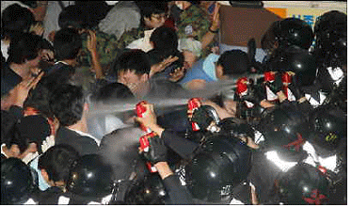

(4) Sidewalk Arrests and Assault, Compulsory Arrest of Protesters
- Yoon-Su Shin (male, 25, Student), May 30th: A riot police bus charged towards people in order to disperse the street demonstration, and one person was hit by the vehicle and injured. When the policeman driving the bus did not step out, the demonstrators crowded the bus in protest. May 31st: At approximately 2am, as a riot police bus that caused a traffic accident moved to leave without an apology, people crowded the bus. The riot police then inflicted violence against these people. Mr. Shin tried to stop the riot police bus from leaving. Several policemen came at him and his back was kicked with boots, his face injured, and one of his contact lenses fell out.
- Suk-Won Yoo (Male, born 1989, College student), June 1st: In the process of arrests at dawn, the police pushed people onto the sidewalk and several policemen surrounded some citizens and assaulted and arrested them. In particular, some citizens protesting on crosswalks were threatened with arrest, and some citizens seeking refuge in nearby buildings were chased after.
- Ji-min Lee (female, 20, unemployed): Was at the City Hall Square, protesting against police violence. The police force was suddenly thrust en mass in her direction. Struck and pressed with shields, she suffered exhaustion.

(5) Violence against the Handicapped
- Min-Suk Kang (female, 42, Unemployed), May 24th: The handicapped victim, who uses a wheel chair, at the time, wore plaster casts on both arms. Despite her complaint of pain due to joint rheumatism, the police pulled at her wrists to take her into custody. At this, she protested and started biting at the hands of the police women holding her wrists, and one of them grabbed and puller her by the hair.

(6) Violence against Young People
- Joon-Suk Choi (male, 13, Middle school student) June 8th: At approximately 5am, , a group of citizens including a 13 year old boy were gathered in front of the Kyobo Insurance building on Sejong crossroads. As the suppression started and the riot police came brandishing their shields, the crowd turned around and started running away. At this point, the boy was hit in the back of the head by a shield wielded by a policeman and fainted on the spot. Citizens and medical staff who witnessed the situation, shouting that a child was hurt, tried to encircle and protect him, but the police kept on pushing on forward, and the several citizens and the teenager became isolated among the police force. The injured boy suffered cerebral concussion and was hospitalized for four days

2. Process of Arrest and Investigation
- Disregard for Medical Treatment Requests
- San Kim (male, 31, Human rights activist): While walking towards the station office after arriving at the Kang-seo police station, he told the police that he wished to visit the hospital. But the request was ignored, and his arm twisted and accompanied by more than three people, he was dragged to the office.

- All-night Investigations and Restricted Bathroom Visits
- Ha-Na Kim (female, 27, Human rights activist): After confrontation with riot policeman blocking a sidewalk near Kyungbok Palace, Ms. Kim was taken into custody at Suseo police station on June 1st, at approximately 3 am. She and others were investigated till 7am.
- So-yeon Chung (female, 24, Human rights activist): May 27th, City Hall Square. Ms. Chung thought she was being sent home but was instead illegally arrested and arrived at the Mapo police station around 12:30 am. She protested against the illegal arrest and refused to make any statements. The police restricted her from visiting the bathroom for three hours and said that she cannot go to the bathroom unless she identifies herself.

- Illegal Arrest and Forgoing Notification of Miranda Rights
- Na-Young Kim (female, 30, Unemployed), May 27th, 11pm: Was taken into custody from the sidewalk without being notified of the Miranda Rights. At the time, the people later taken into custody were heading towards Kwanghwamoon from the City Hall Square and walking on a crosswalk. Then suddenly, riot policemen surrounded the City Hall area and the crosswalk and people passing by were all surrounded by the police. The police encircled people by groups of several, and the five people including Ms. Kim who were at the right side of the Square, surrounded by the police, demanded to be sent home. She could not hear the warning broadcast at all, and when several people asked “Are we being sent home” after the police opened the road, the police at the site answered, “Yes.” But the people were sent in two or threes to the police vehicle and were taken into custody. Ms. Kim arrived at the Mapo Police station at around 12:30am. The victims were twelve in total.

- Interfering with Lawyer Visits
- San Kim (male, 31, Human rights activist), May 31st: Mr. Kim, after taken into custody at Kang-seo police station, at around 2 pm, expressed his desire to visit a hospital. But a police officer replied that a hospital visit is possible only when the person is bound with ropes. Mr. Kim then requested a lawyer, which a detective refused with a reply, “You don’t have rights to a lawyer because you are caught red-handed.” When Mr. Kim protested, all the policemen in the police cell left the room. He continued to request a lawyer visit every half an hour but was ignored, until 7pm, when he could finally meet a lawyer. It has been revealed that the police lied, stating that they called a lawyer at around 5:30pm and requested a visit.

